# **Salute to Sorts**

This will be a shared document. Do NOT highlight your answers because this document will be **PRINTED (print front and back!)** and **stapled** to the handwritten sorting results.. This is an ASSESSMENT grade. You will NOT need to memorize the code for any of the sorts word for word, but you must be able to perform the ALGORITHM (ascending and descending) based on the sort.

1. **Below the code segment for each sort, describe the sort algorithm. Include enough information so that someone who has never seen this sort could perform it based upon your description while looking at the code.**
2. **Discuss any special cases that affect this algorithm, such as completely sorted/backwards array, an array of Strings, etc.**
3. **Finally discuss if this particular code segment results in ascending or descending order and which specific code would need to be changed to switch to sort the other direction.**

**NOTE ON MERGE SORT: The merge() method itself is quite lengthy and takes up a lot of space (which is why you see no implementation). Refer to the actual code on your Standard Algorithms handout. The MOST important part of the merge sort is the mergeSortHelper() method.**

**Topic 62 - Monte Carlo sort (NTK)**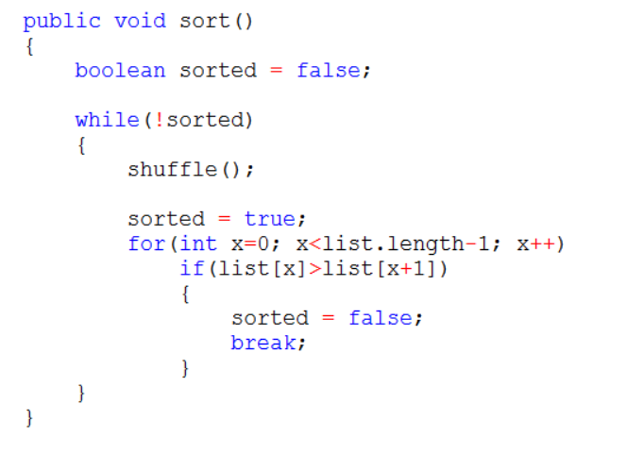

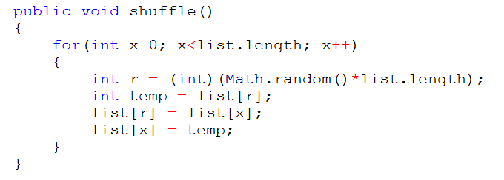

**Monte Carlo Sort:**

**Topic 63 - Linear (Sequential) sort (NTK)**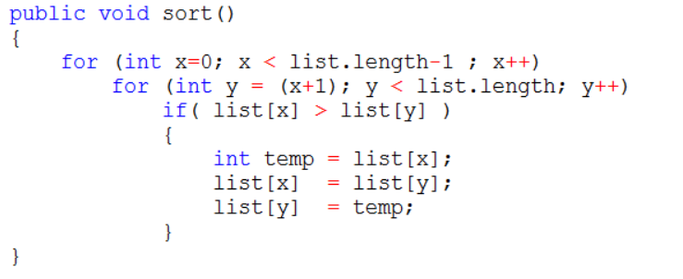

**Linear Sort:**

**Topic 64 - Bubble sort (NTK)**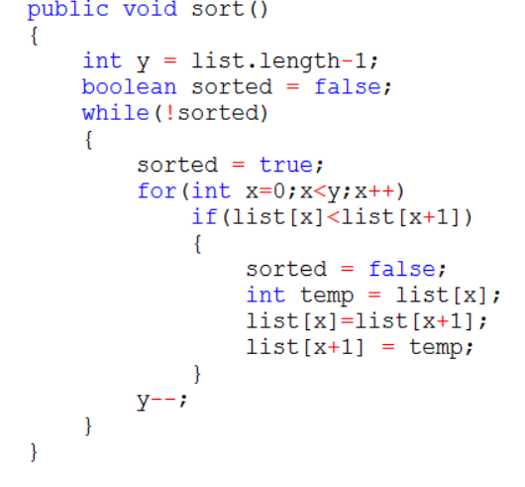

**Bubble Sort:**

**Topic 65 - Selection sort (!MK!)**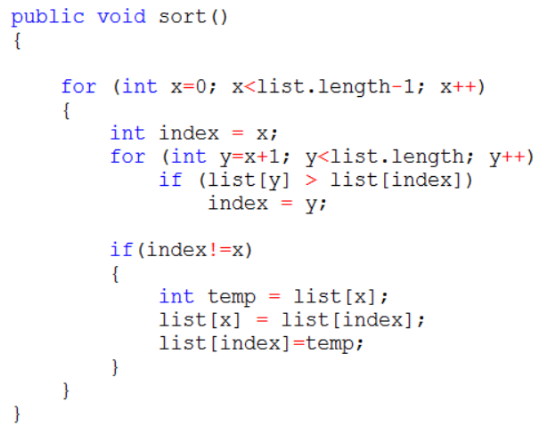

**Selection Sort:**

**Topic 66 - Insertion Sort (!MK!)**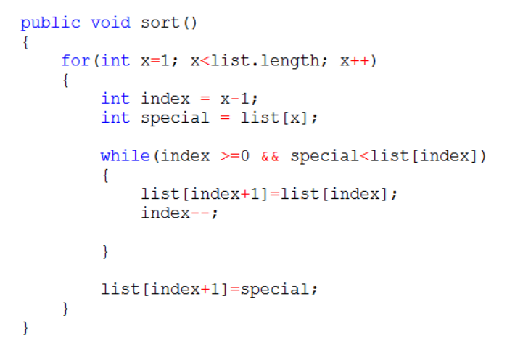

**Insertion Sort:**

**Topic 67 - Merge Sort (!MK!) - THIS IS THE LAST TOPIC!**

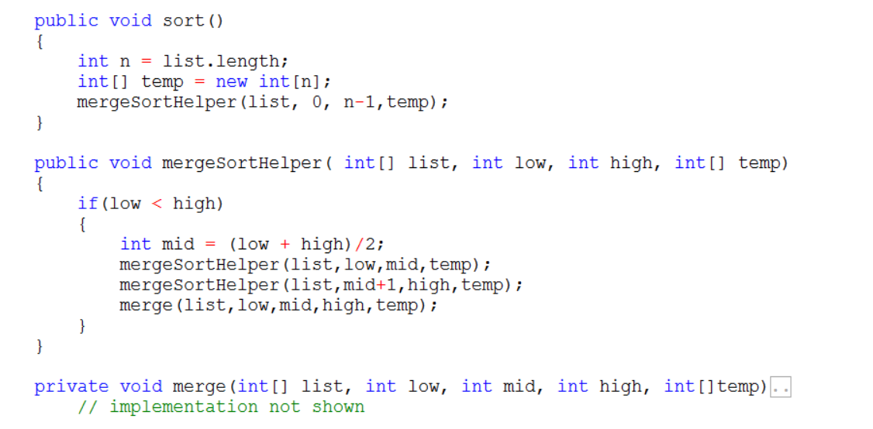

**Merge Sort:**